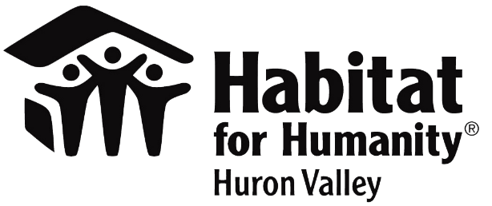
Contact
Alison Oumedian
Habitat for Humanity of Huron Valley
734-882-2009
alison@h4h.org
www.h4h.org

FOR IMMEDIATE RELEASE
Habitat hosts first Habitat FORE Humanity of Huron Valley Golf Classic on September 25 to support COVID effected homeowners and community programs

ANN ARBOR, MI (September, 2020) – Habitat for Humanity of Huron Valley is working to keep families housed and continue its valuable community programs through its first golf outing on September 25 at Lake Forest Country Club, Ann Arbor.

The event will support the organization’s work of renovating homes, home improvement programs for homeowners & veterans, community development, and the new Mortgage Relief Fund which works to keep families affected by COVID from defaulting on their mortgages.

The Habitat FORE Humanity of Huron Valley Golf Classic will be hosted at Lake Forest Country Club. The 18-hole scramble will start at 10 am and includes breakfast, lunch, dinner, and raffle. Tickets are $150 per golfer, $500 for a foursome, or $40 for a dinner only ticket.
For more information, and to buy tickets, please visit www.h4h.org/golfouting or email alison@h4h.org.

As with all organizations, Habitat is working on rebounding after the COVID stay-at-home orders. We canceled all volunteer activities in March – June, and returned to minimal volunteer group work in July. We averaged a loss of roughly 1,050 volunteers during our busiest build and exterior repairs season. This loss of volunteer labor has slowed our project timelines and placed more pressure on our construction team to continue working on priority renovation projects. We estimate volunteers save our organization $24/hour, meaning we anticipated about $168,000 in expenses related to the loss of roughly 7,000 volunteer hours over the course of March through June. Proceeds from this outing will help us keep operating.
Established in 1989, Habitat for Humanity of Huron Valley enriches our neighbors to build better neighborhoods through our volunteer, donation, partnership and ReStore efforts. We build homes, communities, and hope… under one roof. We work to enrich Washtenaw County through a legacy of affordable homeownership for families and individuals of low income. Each year, Habitat serves or assists more than 1,000 families and individuals through its Home Ownership Program, Home Improvement Program, Veterans Program, Financial Education and Community Development Program. Habitat has built or renovated nearly 250 homes and served or assisted more than 5,000 households in Washtenaw County. For more information, visit www.h4h.org.
###

